Asteroid Summary

1. How many known asteroids are out there? This was the first question that came to mind when we began this project and it doesn’t have an easy answer. There is an estimated to be around 2 million asteroids that have relevance to the Earth, but the true answer to our question is 19,700. NASA has data on 19,700 asteroids. The relatively small number of “known” asteroids is due to the limitation on resources. As we can see in the HazardbyYear.png graphic the findings keep going up exponentially:

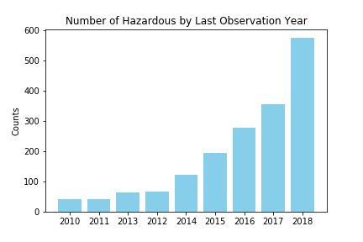

1. What makes an asteroid dangerous? To find this out we first made a scatter plot showing all of the asteroids and color coded them:

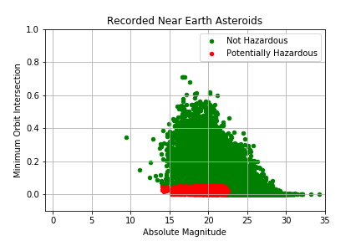

This graphic clearly showed boundaries and when we took a closer look:

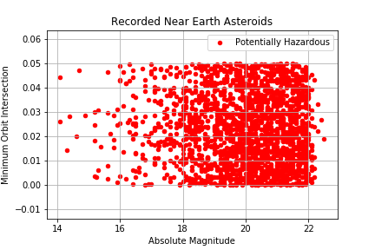

It showed that an asteroid was considered potentially hazardous when it had a Minimum Orbit Intersection Distance of less than .05 Astronomical Units and an Absolute Magnitude of roughly less than 22. Looking up the requirements for a Potentially Hazardous Asteroid showed us that this was exactly the case.

1. Are we able to find out when the next asteroid will hit us? The short answer is kind of. We can sort the data to show us when the next “Close Approach Date” is. The next “close approach date” for known asteroids is 8-23-2019. The problem with this is, we are constantly discovering and tracking more asteroids. For instance, there were 6 “close approaches” for known asteroids in 2018, 6 in 2017, and 16 in 2016, so the likelihood of the next one being in August of 2019 is low.
2. Does the mass or the speed of an asteroid determine if it potentially hazardous? Something interesting was discovered when looking at the mass and speed of an asteroid:

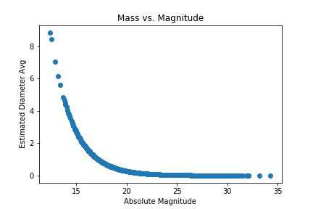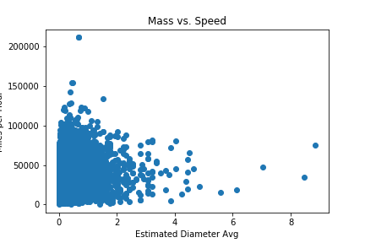

speed vs mass doesn’t tell us much, but the interesting thing to us was that mass and magnitude were inversely proportional. This seems to go against common understanding of magnitude. This led us to looking up information NASA’s definition of absolute magnitude. There we learned that Absolute Magnitude is the brightness of the object. The smaller the absolute magnitude the brighter the object is.